书名: The Foundations of Mathematics (Logic)

作者: Kenneth Kunen

页数: 262

出版社: College Publications

出版年: 2009-09-08

metatheory, kunen's account

Don't read a math book like a novel. Feel free to jump directly to what interests

引自第8页

Some elementary use of logic is needed even to state the axioms, since we need the notion of "formula". However, we're not using logic yet for formal proofs. Once the axioms are stated, the proofs in this chapter will be informal, as in most of mathematics.

引自第20页

1.7.2 Foundational Remarks

1. Set theory is the theory of everything, but that doesn't mean that you could understand this (or any other) presentation of axiomatic set theory if you knew absolutely nothing. You don't need any knowledge about infinite sets; you could learn about these as the axioms are being developed; but you do need to have some basic understanding of finite combinatorics even to understand what statements are and are not axioms. For example, we have assumed that you can understand our explanation that an instance of the Comprehension Axiom is obtained by replacing the if in the Comprehension Scheme in Section 1.2 by a logical formula. To understand what a logical formula is (as discussed briefly in Section 0.2 and defined more precisely in Section II.5) you need to understand what "finite" means and what finite strings of symbols are.

This basic finitistic reasoning (see also Section III.l), which we do not analyze formally, is called the metatheory. In the metatheory, we explain various notions such as what a formula is and which formulas are axioms of our formal theory, which here is ZFC. （pp.28-9）

one often speaks informally of ∈, =, and ⊆ as "relations", but these are not relations in the above sense - they are a different kind of animal. For example, the subset "relation", S = {p : ∃x,y[p = <x,y> ∧ x ⊆ y]} doesn't exist — i.e., it forms a proper class, in the terminology of Notation 1.6.9 (5 cannot exist because dom(S) would be the universal class V, which doesn't exist).

引自第29页

elementary calculus texts (see [60], p. 19) often confuse the issue by defining a function to be some sort of "rule" that associates y's to x's. This is very misleading, since you can only write down countably many rules, but there are uncountably many real-valued functions. 引自第30页

However, the "rule" concept survives when we talk about an operation defined on all sets, such as ∪ : V → V. Here, since V and functions on V do not really exist, the only way to make sense of such notions is to consider each explicit rule (i.e., formula) that defines one set as a function of another, as a way of introducing abbreviations in the metatheory. an explicit example ... the successor "function" ...引自第30页

we used the terminology A ≼_{\phi} V when discussing absoluteness (see Definition II. 17.7). For a specific (f, it is clear what this means — it is an abbreviation in the metatheory for the longer statement \forall \overset{\rightarrow}x \in A [\phi^A(\overset{\rightarrow}x) \leftrightarrow \phi(\overset{\rightarrow}x)] ; this makes sense whether A is a set or a specific proper class.

引自第177页

By Godel's Second Incompleteness Theorem (IV.5.32), a consistent theory cannot prove its own consistency. So, if you have a formal system that you believe is really true, then it must be consistent, and then the consistency of that system is a true fact not provable by the system. This issue is largely irrelevant to formalists, who have agreed not to discuss in depth the truth of their formal systems.

引自第189页

Roughly, as we said, the metatheory is basic finitistic reasoning about finite objects such as finite numbers and finite symbolic expressions. One could attempt to give a precise definition of exactly what finitistic reasoning is — for example, we could say that it is what can be formalized within the system PRA mentioned above. But if you look at the definition of PRA (or of any other formal system), you will see that to understand the definition, you need to understand already basic finitistic reasoning. That is, starting from nothing, you can't explain anything.

引自第190页

note that formal logic must be developed twice. 引自第191页

For example, consider our discussions of the ZFC axioms. The statement "Axioms 1,2 \not|- Axiom 4" can be viewed either as a finitistic assertion in the metatheory, verified with a one-element model as in Exercise 1.2.1, or as a theorem formalized within ZFC. However, the statement "ZFC-P \not|- Axiom 8 (Power Set)", which requires an infinite model, such as H(\aleph_1), can only be thought of as a formal theorem of ZFC. However, if \Sigma is the set of axioms ZFC-P plus the negation of Axiom 8, then the implication "Con(ZFC) -> Con(E)" may be viewed as an assertion in the metatheory; the finitistic argument is: If \Sigma is inconsistent, so we are given a formal proof of \phi \land \lnot\phi from \Sigma, then we may use this to construct an inconsistency in ZFC by showing, in ZFC, that the statement H(\aleph_1) |= \phi is both true and false.

引自第191页

elementary school arithmetic is part of the finitistic metatheory, and is used in developing logic (e.g., we induct on the length of a logical formula). 引自第192页

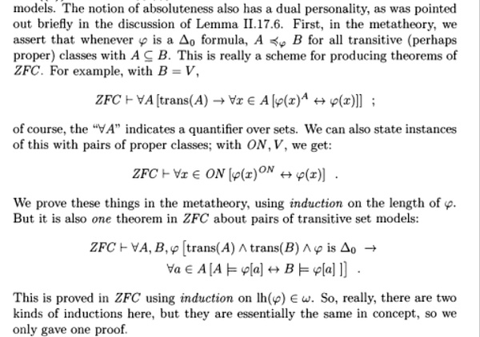

p.192

the independence results really produce an algorithm that, given as input a proof of CH or \lnot CH from ZFC, will output a proof of contradiction from ZFC. This can all be understood finitistically, without any belief about whether or not ZFC is consistent. Also, as explained in Section IV.5, the Incompleteness Theorem applies not only to ZFC, but to arbitrary extensions of CST, which may or may not be consistent. It really produces an algorithm that, given such an extension Υ and a proof of Con(Υ) from Υ, will output a proof of contradiction from Υ.

引自第193页